SDM for Green Peafowl

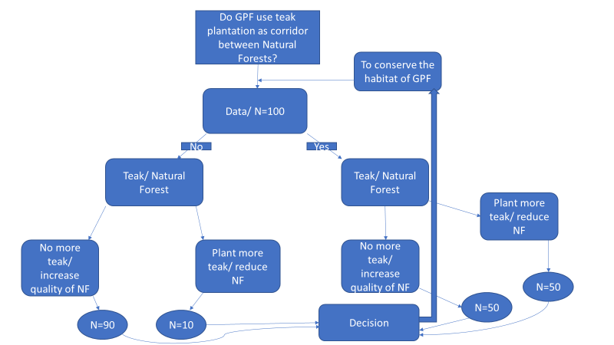

This is the flow chat for habitat conservation of green peafowl. I want to know that do the green peafowl use teak plantation as corridor between natural forest patches? First, I need the data and here I estimated the population of peafowl is 100 individuals.

Then if the peafowl are using the teak plantation as corridor, planting more teak and reducing natural forest is not affect the population as we do not plant more teak in the area.

But when the peafowl are not using the teak plantation as corridor, planting more teak and reduce natural forest is more negative affect than increase quality of natural forest and not plant more teak in the area.